**COSC2543 Mobile Application Development**

**Assignment 2**

**Android Application Proposal**

|  |  |
| --- | --- |
| Semester | 2012B |
| Student 1 (ID & Name) | s3298809 – Vu Xuan Bach |
| Student 2 (ID & Name) | S3298775 – Le Hoang Hai |
|  |  |

* **Executive Summary**

Our application is designed for users to share pictures they just took from their phone camera with friends through a social network.

* **Application requirements**

Screen size: WVGA 800

CPU: 600 MHz

OS: Android 2.2 (but 2.3.3 for emulator)

* **Application’s functionalities.**
  1. Register Screen: for users to create new account.
  2. Function login: Login in to start using the app.
  3. Home page: show the most recent pictures of you and your friends.
  4. Comment: you can comment your own pictures or friend’s pictures.
  5. Like: you can like the pictures.
  6. Location: Get the location of the user when taking picture.
  7. Main & Explore page: see public picture from other users.
  8. Button snapshot: let you take a picture and share it with your friends.
  9. Crop and image filter: edit the picture after taking it.
  10. News page: you can see your friends and users pending to be your friend.
  11. Phone friend: call friend from the application.
  12. Manage friend: you can add delete friend, accept pending users and call your friends.
  13. Profile page: show username, avatar and photos your have taken.
  14. Preference page: find and add new friends, see photos you liked, edit profile, settings and logout.
  15. Widget: Show pending friend request and the recent posts.
* **Screen Design and Information Flow using** <http://www.droiddraw.org/> **or paper’s sketch.**

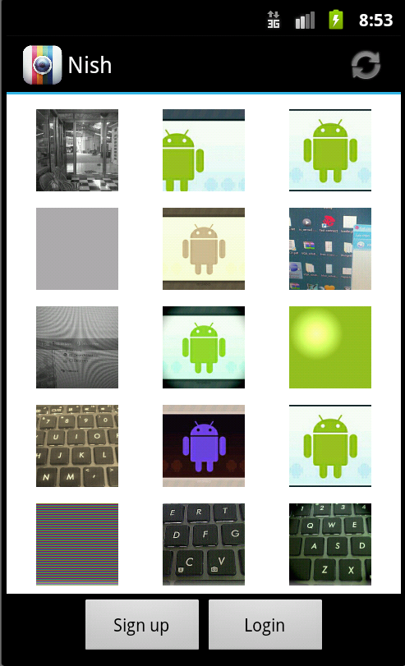 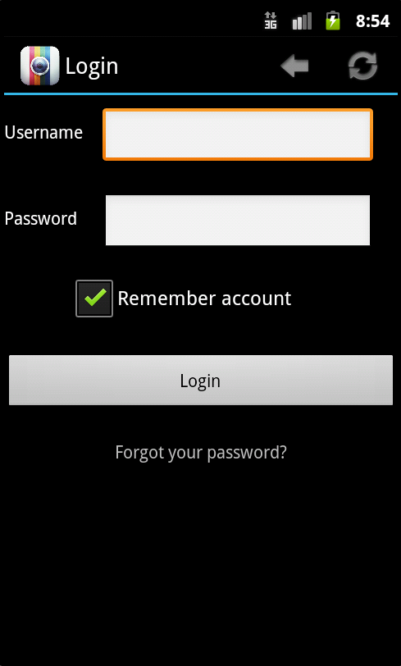 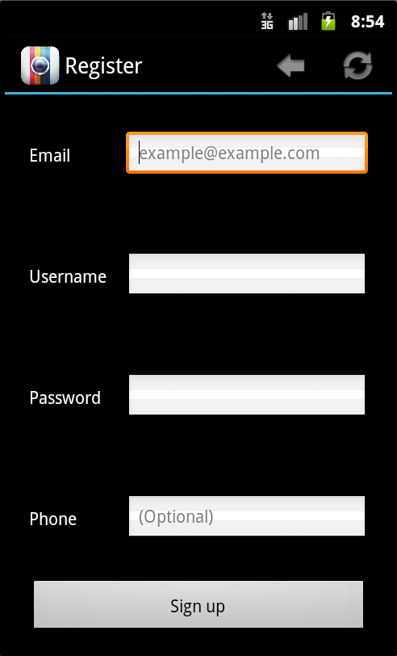

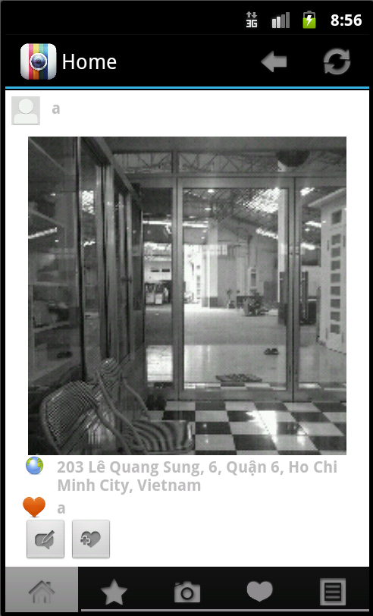 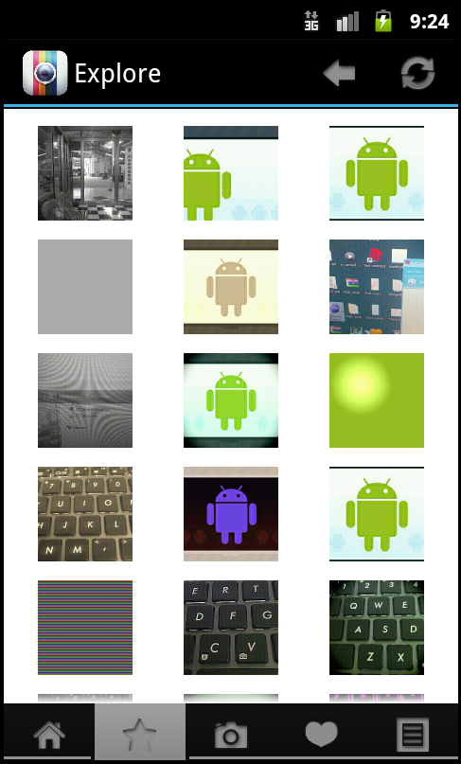 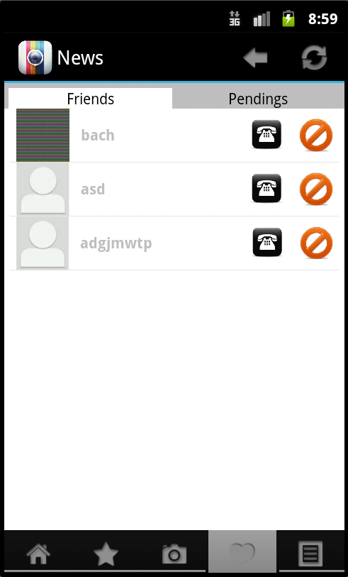 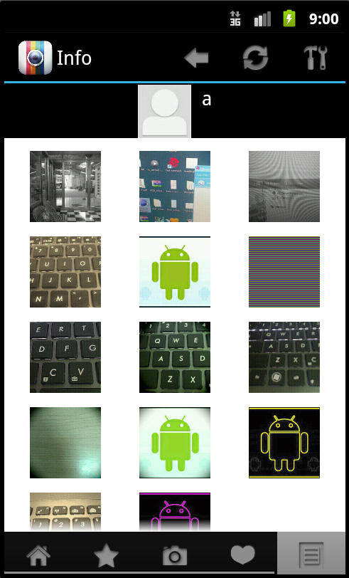

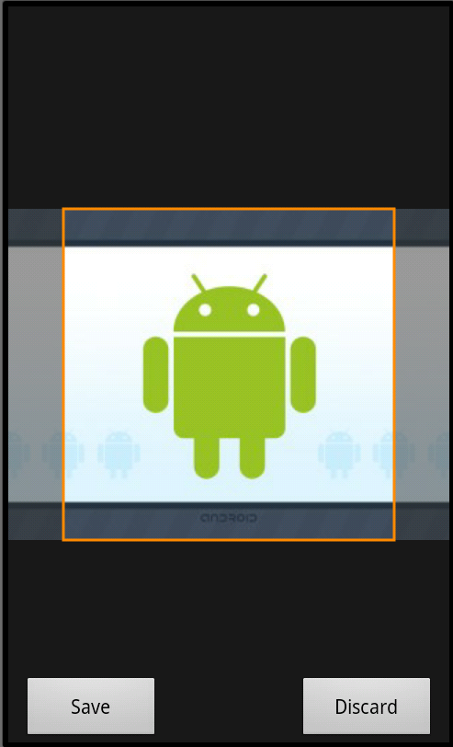 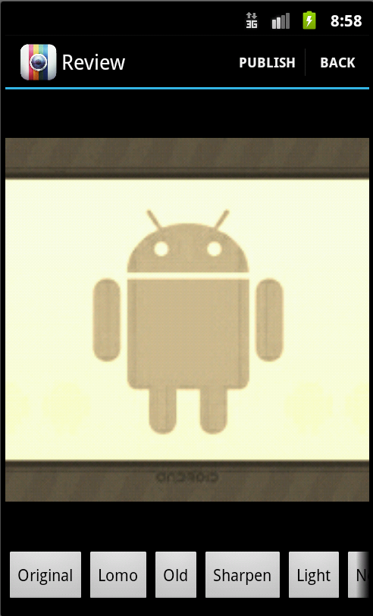 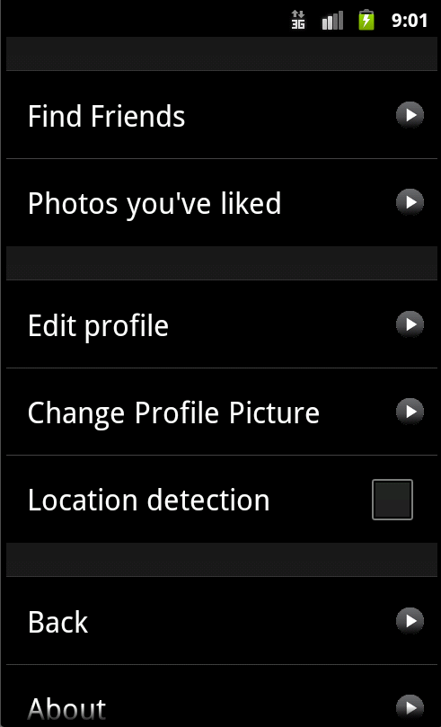

**Applied Areas**

* Location API: Sharing your current location by getting latitude and longitude.
* SQLite DB: Remembering ID & password of last login user. Storing friend lists and pending lists of current users to boost performance.
* Telephone handling: Calling friend from the application.
* Network Service: Connecting to Parses server and database.

*PS: This proposal includes 2 copies: 1 for student, 1 for lecturer*

Student Signature Lecturer Signature